2-2 Project One Milestone One
Tamani Harrison
Southern New Hampshire University
IT: 423 Computing as a Service
Instructor: Sean Stinehour
July 19, 2026

Entity relationship diagrams (ERDs) represent the data portion of a cloud-based database. For this reason, ERDs are often used to communicate how information is stored in a database. Describing the entities, attributes, and relationships that go into a specific database ensures that the cloud database you create actually supports organizational operations. You want to avoid creating a database that stores irrelevant data.
For this milestone, imagine that you are a solutions architect at a start-up organization called Your Online Database Architecture for Education (YODAE). YODAE is an educational technology company that is quickly growing and scaling its services. Teachers, educators, and administrators in the K–12 education industry use its cloud solutions. You will design the cloud database to implement a cloud-based system that meets YODAE’s educational clients’ needs.
Review the YODAE Business Case in the Supporting Materials section to gain a better understanding of YODAE and how your cloud solution will meet its organizational needs and operations. You can use LucidChart to create your diagram, which will automatically generate the corresponding SQL code for you. You may also use another software application of your choice to create your diagram; however, you might need to write your SQL code yourself. Note that you will only submit a screenshot of your diagram for this milestone. However, you will need to use your ERD in Project One Milestone Two, as well as part of your Project One submission, so ensure that you save it.

Directions
To complete this milestone, you must address the following rubric criteria:
- Entity Relationship Diagram: Create an ERD that meets organizational and user needs.
  - The ERD must show the cloud database system architecture as part of the cloud-based database design.
  - To create your ERD, refer to the YODAE ERD Example in the Supporting Materials section. This example already includes some components of your diagram. Add to this diagram by including the following components:
    - All of the appropriate entities: What entities described in the business scenario does the ERD need to include?
    - All of the appropriate attributes: What are at least five attributes for each entity?
    - Necessary relationships: How will the relationships between the entities be accurately presented in the diagram?
- Explanation of Entity Relationship Diagram: Explain how the components of the ERD will meet the organizational needs.
  - How does your diagram meet the needs of YODAE and its clients?
  - Explain the entities, attributes, and relationships depicted in your diagram.

Entity Relationship Diagram:
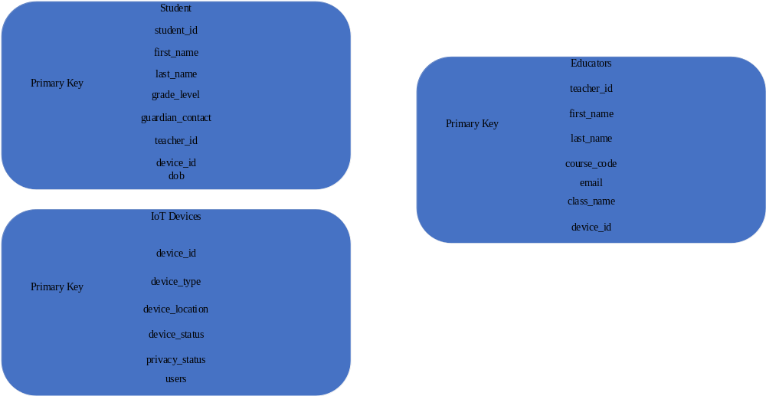

This entity relationship diagram incorporates YODAE’s priorities for a better management system. This entity relationship diagram provides educators, administrators, & students with a simplified user experience that supports the organization's needs. Each primary key addresses specific requirements set forth by YODAE. The student entity stores vital data about the student. The educator entity logs data related to teachers. The IoT Devices entity section stores information about Internet of Things devices by students & educators.
The student section contains student identification, first & last names, grade levels, guardian contact info, current teachers, date of birth & accessible IoT devices. This information helps school administrators & educators easily track student information & device permissions across the school database. If a student is transferred to another school, their device ID can be transferred to another student in need of an IoT device. This mitigates potential headaches that could arise from IoT devices being stolen or lost due to poor accountability.
The educator entity contains important information regarding educators, such as their identification, first & last names, curriculum code list, school email addresses, class names, and assigned IoT devices. This information allows schools to identify that an educator is who they claim to be. YODAE clients will enjoy having this information available. It allows them to log important student & teacher information. It also lets them keep an eye on how students & teachers get along via email monitoring.
The Internet of Things device section identifies each device connected to the school network, what kind of device it is, where it is located, who is using it, and the device's status & privacy status. These settings are necessary to prevent rampant misuse of school hardware by both teachers and students. Knowing where the device is and what its status is helps IT staff account for each device & that the devices are being used for their intended purposes. Device type & ID help improve school security by allowing each device on the network to be clearly seen. This allows access controls to be restricted to student & educator’s needs. Each IoT device can be monitored by checking each device's privacy status to make sure there is no breach in the device's privacy configuration.

